Guide to Using Generative AI in VC

Table of Contents
- General
  - Introduction to Generative AI
  - The Full Stack
  - Prompts
  - Tokens
  - Context Management
- Agents
  - Claude
  - ChatGPT
- MCPs
  - Microsoft
  - Affinity
  - Raylu
  - Egnyte
- Example Use Cases
  - Email Generation
  - Company Analysis
  - Market Research
  - Egnyte File Search
  - Memo Generation
- Tips and Tricks
  - Subagents

General
Introduction to Generative AI:
Generative AI is nearly omnipresent in our modern society, being used in every industry, every market, every field, and it’s only growing increasingly integrated with the systems we interact with. As a result, it is imperative to understand what it is and how to best utilize it as a tool to unlock the potential it holds.

Firstly, you might be wondering what exactly the term Generative AI refers to:
Generative AI is a type of Large Language Model
Large Language Models are machine learning models trained upon countless datasets of text and identifies contextual patterns between them to make sense of language
Generative AI utilizes the learned context to understand commands inputted by users – which are called prompts - and return generated outputs in response.

Generative AI has advanced to a point where it can take in a prompt, extrapolate it to a multi-step set of instructions for itself, and execute those operations accordingly
e.g. Claude is a Generative AI model, and the Cowork function converts your singular command into a series of actions it processes sequentially:

Prompt

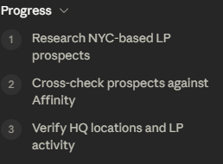
Extrapolation:

The Full Stack:
Before getting into prompts and tools, it helps to see the whole pipeline a generative AI response travels through — from the hardware it runs on to the words that land in your chat window:
- Data Centers – Models are trained and run on massive clusters of specialized chips (GPUs/TPUs). This compute is the single biggest cost driver behind every AI product, including the token costs discussed below.
- Training – The model is first pretrained on enormous datasets of text, code, and images to learn language and patterns, then fine-tuned (including human feedback) so it reliably follows instructions and stays within safety guardrails.
- Deployment – Once trained, the model is hosted behind an API and packaged into the products we actually use (Claude’s Chat, Cowork, and Code; ChatGPT; platform-embedded agents like Affinity Ascend or Raylu).
- Your Prompt – You send an instruction through one of those products.
- Inference – The live model tokenizes your prompt, reasons over it (sometimes visibly, as “thinking”), calls any tools or MCPs it needs, and generates a response. This is the step where model choice and effort level (both covered later in this section) matter most.
- Output – The generated result is streamed back to you as text, code, a file, or a completed action.

For a deeper dive into this, please refer to the AI Industrial Roadmap in the Tools folder of the Egnyte drive.

Prompts:
The MOST important skill when using Generative AI is prompt engineering.

As introduced above, all commands will be interpreted by the model and contextualized to produce an output based on what the model thinks you wanted from the command.

Thus, it is imperative to give specific, precise, clear, direct, context-rich prompts to the AI.

Example:
Exhibit A: | Exhibit B:
Prompt: “Write an email for a meeting”  Output:  Dear [Company Name] Team,  My name is [Your Name], and I am reaching out on behalf of [Your Company Name]. I would like to schedule a meeting to discuss [topic/purpose, e.g., a potential partnership, project proposal, service offering].  Would you be available for a call or meeting sometime in the coming week? I'm happy to work around your schedule — please let me know a few times that would suit you, or feel free to suggest an alternative.  For reference, the meeting would likely take about [30 minutes/1 hour], and I can meet either in person or via video call, whichever is more convenient for you.  Best regards, [Your Name] | Prompt: “You are on the sourcing team at a venture capitalist firm. Create an outreach email containing the following:  1. A warm introduction expressing interest in specific attributes of their product  2. Mention relevant companies in our portfolio  3. Posit yourself as an expert in the industry/sector/market they are in  Output:  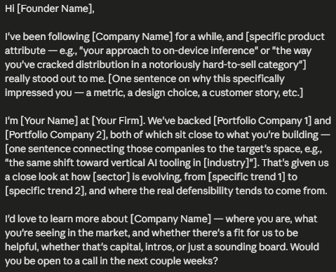  Best, [Your Name]
General Guideline to Prompting:
- Provide Context
- Try to picture what you want the AI to produce
- Compartmentalize it into smaller components
- Describe each component from the previous part in full
- Don’t make the AI guess what it thinks you want
- Be Specific
- Direct the model’s focus towards the objective you want
- Be as precise as possible when describing desired details
- Avoid using “fluff” words, which could cause it to deviate
- Building on the Conversation
- Sometimes, no matter how specific and contextualized your prompt is, the AI still may not produce exactly what you want
- They are, however, equipped with memory of the past prompts in a given instance, allowing you to continue prompting it with established context

Some Effective Types of Prompts:
- Shot Prompts
- In these prompts, you provide the AI examples of your output
- This gives it a template to mimic and learn from
- Instructional Prompts
- Use actionable verbs to directly instruct the AI on what to do
- Be sure to give additional context so the AI doesn’t extrapolate randomly
- Role-Based Prompts
- Ask the AI to assume a specific role or viewpoint at the start of the prompt
- Adds specification AND context, yielding a higher quality output
- System Prompt
- Make use of the AI’s memory during a conversation
- Establish a set of rules you want the AI to follow in subsequent prompts
- Pipeline Prompt
- Provide the AI with a clear instructional pipeline so it doesn’t extrapolate
- Most hallucinations come from faulty extrapolations, so use this for complex tasks that you would like to avoid hallucinations in
Guide to Prompt Engineering: https://www.kaggle.com/whitepaper-prompt-engineering
Example Prompt Use Cases:
Shot Prompt | Prompt: "Here are three examples of how I format IC memo executive summaries: [examples]. Using this exact structure and tone, draft the executive summary for Acme Robotics."
Instructional Prompt | Prompt: "Summarize the attached term sheet in five bullet points, covering valuation, liquidation preference, board composition, pro-rata rights, and vesting."
Role-Based Prompt | Prompt: "You are a senior associate evaluating a Series A SaaS company. Review the attached pitch deck and flag any red flags in the unit economics and retention metrics."
System Prompt | Prompt: "For the rest of this conversation, format every company summary you give me as: (1) one-line description, (2) market, (3) traction, (4) key risks. Apply this to every company I mention from here on."
Pipeline Prompt | Prompt: "Step 1: Extract all financial metrics from the attached data room. Step 2: Compare them against the sector benchmarks I’ve provided. Step 3: Flag any metric that deviates more than 20%. Complete each step fully before moving to the next."

Tokens:
Tokens are the currency that these AI models consume to process inputs and outputs.
Evidently, token costs go hand in hand with prompt engineering, another reason why it is important!

Each token is equivalent to roughly 4 characters of English text, or about ¾ of a word.

These tokens have real costs, and the main appeal of subscription services for AI models is the increase to the token rate limit.

As such, it is incredibly important to be aware of one’s token usage and optimize it.

First, however, we must understand how exactly the AI processes prompts:
Whenever you input a prompt, the AI will tokenize it as such:
What is HighlandX [What] [is] [HighlandX]
It reads the tokenized version of the input to understand how each token relates to one another to understand exactly what is being asked of it.

After reaching a certain point of comprehension, it will produce an output
“HighlandX is a venture capitalist firm…”

Technically, the only token costs should come from the input and output. Most modern AI models, however, will access past context in the conversation and scrape the web for additional context and information.

Because these make up the bulk of the costs, AI agents provide options to use different models and effort levels, which set limits on maximum token usage.
While those limits are implemented to prevent excessive token usage, they also place hard limits on functionality, so it is important to know how to utilize higher quality models while finding ways to circumvent token costs in other ways.

Tips and Tricks:
- Compacting Conversation
- As mentioned above, modern AI models will access historical context stored within the sessions context window.
- Subsequent prompts grow exponentially more expensive, as the AI will refer back to each previous prompt and response every time
- To circumvent this, you can ask the AI to compact the conversation and you can use it as a System prompt in a new context window.
- This helps preserve most of the context while reducing token usage for further conversations and prompting.
- Using Subagents
- When you have a task within a complex workflow that you think a less token intensive model can handle, ask the AI to deploy subagents
- You may be wondering, why use subagents rather than just switching the model type and effort?
  - This is because each time you change to model type or effort, it will refresh the AI’s contextual window, forcing it to read through the entire conversation again to understand the current context
- Especially with large volumes of tasks (e.g. cleaning up an Affinity list), deploying subagents will reduce costs immensely
- Forking
- Say you have a very complicated problem, but are able to break it down into smaller, sequential, independent tasks
- If you wanted to process each task in a sequential window, the AI will refer back to the previously done tasks each time, even if they are unrelated to the current task at hand
- There is often a “Spin off a new task” button that allows you to preserve context up to a certain point and \those two threads operate separately
Keep in mind that choosing the effort level and model type is very circumstantial, and the exact process of deciding such will be discussed in the later section about Agent Specifics.

Context Management:
We can think about context as the AI’s “memories” and the context window as it’s “brain”.

Here is a diagram depicting how context windows behave:
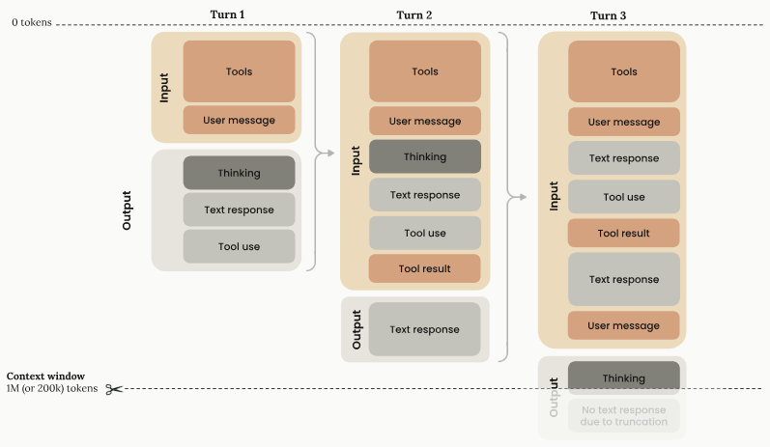
Lets break this down:
- Everything from past turns are carried over to the next except thinking
- Past thinking is forgotten upon a new prompt inducing new thinking
- Tool configuration, use, and results are all separate token consuming processes
- Once a context window has no more allocated tokens, it stops all processes

While, having a context window with greater capacity can allow for more complex and nuanced responses, more context isn’t always better.
Context rot is a phenomenon where, as more and more context is compiled, it reaches a point where it becomes too cluttered, degrading accuracy and recall.
Thus, it is extremely important to keep the context window manageable.

Here are some ways to do such:
- Compaction
- This method was already covered in the above section
- The exact reason why compaction reduces tokenage is because in order to retain the same accuracy in an enriched context window, the AI must check itself more because of context rot, leading to longer thinking
- Context Editing
- This method is all about curating what you want Claude to remember and clearing out any irrelevant or distracting information
- The most common methods of doing such are:
- Tool Result Clearing
  - As seen in the context diagram window above, tool use takes up a lot of context, so getting rid of tool results you don’t need anymore can be extremely effective
- Thinking Block Clearing
  - This is the same as for tool results, where the thinking blocks can consume large amounts of context (especially in longer thinking periods) and it is important to manage the space it occupies
- Prompt Caching
- Prompt caching process is perhaps the most effective method, as it essentially acts as a filter that checks for similar content in prompts
- Each message, either as a whole or parts of it, is marked as a breakpoint, with each breakpoint being stored and saved in the AI’s memory
- There is a limit to the number of markings per prompt, and the priority for these markings are tools, system prompt, and messages in that order
  - So the model will prioritize saving information about tool use, then systematic inputs, and finally simple back and forth chatting
- TLDR: prompt caching makes it so the past context is stored externally and is already processed instead of needing a complete reset each time

IMPORTANT: These are only relevant when applied to the AI’s base model, as the agentic version (the one you interact with through the app and website) does these automatically

Agents
So far, I’ve used the term “agent” a few times and you may be wondering what it means.

As defined by the website describing AI terminology linked in the footnote of each page:
Agents are autonomous or semi-autonomous AI entities that can perform tasks, make decisions, and call tools or APIs based on goals. In academic and enterprise settings, agents are often used to automate workflows like document summarization, task routing, or multi-step reasoning.

The AI tools we know by name and use every day, like ChatGPT and Claude, are all agents.

What is important, however, is that different agents have different specifications and thus different use cases.

In this section, I will go through how to properly utilize the different generative AI agents commonly used in this firm.

General Guideline:
Claude | - More natural language (avoids generic AI phrasing)  - Optimized for complex tasks (e.g. analysis, coding, summarizing)  - Better accuracy when extrapolating vague prompts
ChatGPT | - More functions and versatility (image creation, voice mode)  - Higher usage limits (better for monotonous, but high-volume tasks)  - Better efficiency for web scraping (not necessarily more accurate)
Platform Specific | - Great for sourcing data within the platform  - Specifically trained for the platform’s data

Claude
Claude is arguably the most powerful and effective publicly accessible model.

To start, there are three modes a user can interact with Claude through:
- Chat
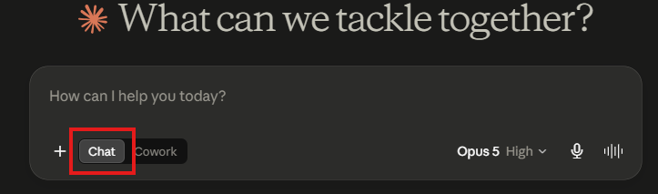
- Cowork
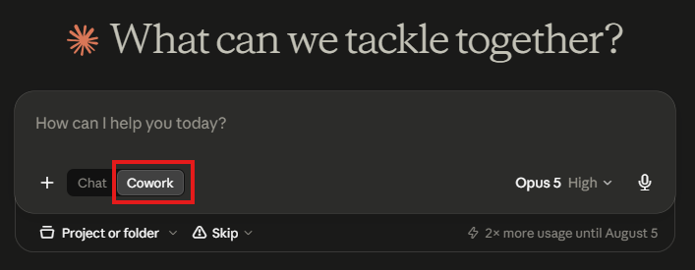
- Code
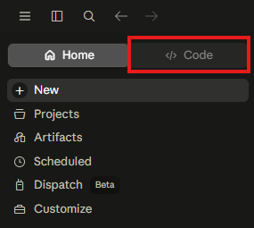
Pros and Cons of Each:
Chat | Pros:  - Best for quick tasks and one-off questions  - Use like it is a highly powered search engine  - Very convenient, just need to open Claude  Cons:  - No MCP connectors  - Poor at multi-step processes  - Context is not saved (bad for repeating tasks)
Cowork | Pros:  - Can access and edit real files from a folder of choice  - Access to connectors  - Can create scheduled tasks and dashboards for recurring work  - Best mix of functionality and convenience  - Operates on SDK; will perform context management for you  Cons:  - Requires some set up  - Most token intensive
Code | Pros:  - Most robust outputs  - Works directly in your files  - Very customizable; best at maintaining context  Cons:  - Language output is less precise  - Terminal restricted  - Unnecessary for non-code work  - Requires set up and configuration

TLDR:
- Chat: best for small, quick, one-off tasks; the most convenient
- Cowork: best all-around for analysis, workflows, and overall reliability
- Code: best for building rigid file infrastructures and working in command prompt
General Features:
Chat, Cowork, and Code are tailored for different purposes, but still operate through Claude, which means they all share certain features and capabilities.

List of Features:
- Adaptive Thinking
- As you use Claude, it learns how much time and effort it should spend in “thinking mode,” which is just it’s extrapolation process
- It also learns to adapt its outputs to better fulfill your prompts as well
- Batch Processing
- Batching allows you to process a large quantity of request simultaneously
- This is best used when the requests don’t need context from one another
- This can save token costs up to 50%
- Built-In Tools
- Claude has numerous built-in tools that often run in the background:
  - Memory tool
  - Bash tool
  - Text editor tool
  - Computer use tool
  - Web search tool
  - Web fetch tool
  - Code execution tool
  - Advisor tool
  - Tool search tool
  - MCP connector
- Claude even allows you to make your own custom tools
- Agent Skills
- Like tools, Claude stores a catalog of skills it learns as you use it
- While tools are individual actions, skills are like pre-built prompts that are automatically processed whenever you explicitly request Claude to execute the skill or if it recognizes a similar set of instructions as before
  - E.g. as I was cleaning the Affinity deal’s list, Claude learned the “Set to Pass” skill, which was prompted whenever I uploaded a list of company domains
- Tools and skills will be discussed in greater detail later in this guide
Models:
These are the real difference makers, as different model-effort combinations have different capabilities, token costs, and consequently, different use cases.

At the time of writing, Claude currently has four models:
1. Fable | Pros:  - Highest reasoning ceiling of any Claude model; built for the most demanding, long-horizon agentic work  - 1M-token context window with the most thorough thinking available  Cons:  - Most expensive tier (~$10 / $50 per million input/output tokens)  - Overkill (and slower) for routine, well-defined tasks  Best Use:  - The hardest, highest-stakes work (e.g. curating a diligence memo)
2. Opus | Pros:  - Strong complex reasoning and coding; Anthropic’s recommended starting point for most workloads  - 1M-token context window  Cons:  - Still costly (~$5 / $25 per million tokens) relative to Sonnet  - More capability than most day-to-day tasks require  Best Use:  - Complex agentic workflows; multi-step tasks; coding; detailed analysis.
3. Sonnet | Pros:  - Best balance of speed, intelligence, and cost (~$2 / $10 per million tokens)  - 1M-token context window; the default for most associate work  Cons:  - Falls short of Opus/Fable on the very hardest reasoning tasks  Best Use:  - Day-to-day work (email drafting, company research, etc.)
4. Haiku | Pros:  - Fastest and cheapest tier (~$1 / $5 per million tokens)  - Near-frontier intelligence for its speed and cost  Cons:  - Smaller 200K-token context window  - No adaptive thinking, complex reasoning, or effort parameter  Best Use:  - High-volume, simple, latency-sensitive tasks

Effort:
Effort is used to control how many tokens Claude spends when responding to requests.

Claude has the following 5 levels of effort:
Low | - Most efficient  - Significant token savings but with capability reduction as a trade-off  - Best for simple tasks that should be optimized for speed
Medium | - Moderate token savings and moderate capability reduction  - Best for agentic tasks with slight extrapolation
High | - High capability; equivalent to not setting a token limiting parameter  - This is the default effort for Claude  - Best for tasks that require complex reasoning
xhigh (Extra High) | - Tailored for extended tasks  - Best for problems you want to query and let Claude process slowly
Max | - Maximum capabilities with no token constraints  - Use only for tasks requiring extremely deep analysis and reasoning  - Best paired with long, in depth prompts

Best Practices:
- Consider the complexity of your task
- Is my task simple and robotic or is it complex?
- How good is my prompt? How much does Claude need to extrapolate?
- Use small samples to test the current model-effort configuration’s effectiveness
- If it has critical flaws, consider upping the capabilities
- If it produces excessive output, consider lowering the costs
- Maintain the same model and effort within a single conversation
- As mentioned earlier, switching the model and/or effort refreshes Claude’s context and it must process the entire conversation again
- Instead, think about compacting the conversation and continuing it in a fresh context window before testing different model-effort configurations

Memory:
Claude is equipped with the capability to search through the context of your previous conversations and sessions to find or reference relevant information in new chats.
- E.g. if you compare two companies you researched in different sessions, Claude will be able to draw information from both in a single session

Of course, this creates a lot of misinterpretation from the extreme amounts of information that gets compiled over time, and Anthropic created a few ways to combat this:
- Disable memory
- There is a toggle in Settings Memory that you can turn on or off
- Exclude specific chats
- While you cannot remove a chat from memory, you can use incognito chats that won’t be saved in memory
- Reset memory
- This is a hard reset that should be used if Claude is too unfocused
You can view and edit your memory in Settings Memory.

You can also query Claude to remember certain parts of the conversation through prompts.

Projects:
Projects are another feature in Claude that allows us to make full use of memory.

Projects are self-contained workspaces with their own chat histories and memory spaces.
- This makes it so memory is streamlined and relevant for only items within the project

Projects essentially act as organizational devices that allow us to center Claude’s focus around a certain theme/topic.

Artifacts:
Claude can produce its own complex pieces of content such as:
- Documents
- Code Programs
- HTML Websites
- SVG images
- Diagrams and flowcharts
- Interactive React components
These are called artifacts and are the most powerful outputs Claude can provide.

Here is a powerful artifact that I built (Daily Media Digest):
- Prompt:
My firm is concerned with companies that deal with AI native and SaaS infrastructures. Can you tailor an HTML artifact that searches my X and LinkedIn feed for posts related to those themes and create a digest presenting information on both the market and the company? Make it an interactive window with tabs to switch between company news and market news. Furthermore, add a function that allows filtering from just X posts and just LinkedIn posts. Finally, add a function that allows you to view the post the data is derived from.
- Output: claude://cowork/shared-artifact?uuid=01a01566-dcea-73eb-8f75-73586e8898eb

Artifacts can be constantly fine-tuned by simply prompting Claude, and past versions are also easily accessible.

You can even make your artifacts AI-powered by prompting Claude to add itself to it.

Artifacts store data across sessions (e.g. imagine a journal artifact that stores past entries).

Tools:
Claude automatically determines when to call a tool based on the prompt and matches it with any tools with a corresponding description (you can also specify it to use a tool).

Once a tool is called, Claude allocates the amount of context (tool use) needed to run the tool and it will return a structured output in another block of context (tool result).

This output will then be used and integrated into its final text response.

Claude has built in tools, but also allows you to define your own tools and here is how:
- Prompt Claude that you will be creating a tool
- Specify the following
  - What the tool does
  - When it should or shouldn’t be used
  - What each parameter means
  - Any important caveats or limitations you might encounter
- Provide input examples for the AI to reference
- Consolidate related actions into a singular tool
  - Rather than a read_excel, write_excel, and export_excel tool, you can just merge them all into a single excel skill
- Use unique and meaningful names so the AI doesn’t confuse the tool call with a similarly named tool
These are especially helpful if you have repetitive, custom use cases that Claude can fulfill

Best Practices:
- Provide extremely detailed descriptions of what the tool does, when it should be used, what each parameter means, and any important caveats
- Use example input and output pairs as context for Claude to follow

Skills:
Skills are set of instructions packaged into a folder that teach Claude how to handle specific tasks or workflows.

In this section, we will go over how to create your own powerful tools to personalize and maximize the effectiveness of your Claude profile.

Skills are structured to minimize token usage while maintaining specialized output

Skills are most powerful when you have repeatable workflows
- E.g. conducting research with a consistent methodology

As mentioned above, a skill is a folder, and it contains the following contents:
- SKILL.md
- This is a markdown/text file that contains the instructions for Claude
- scripts/ (optional)
- This contains any executable code programs you want Claude to run
- references/ (optional)
- This is used to support the scripts by providing useful documentation
- assets/ (optional)
- This can be anything that helps structure the output (templates, font, etc)

Claude can load multiple skills simultaneously, with the skills working with each other

Skills can also be used in tandem with MCPs:
Kitchen Analogy:
The MCP is the tools, ingredients, and equipment
The skills are the recipe book
Now, let’s begin the process of making our own skills:
- Planning and Design
- Before writing anything, ask yourself these questions:
  - What do I want to accomplish?
  - What multi-step workflow would be involved?
  - What tools are needed?
  - How helpful would this really be?
- Once you’ve confirmed the scope of the skill, brainstorm 2-3 use cases
- Next, define your success criteria:
  - How do you know the skill is working?
    - Check for errors or failed API calls
  - Is the skill being called for the right tasks?
    - Test prompts you would expect the skill to be called in
  - Is the output what you expect?
    - Again, test prompts and evaluate the accuracy
  - Does the skill even make the process more efficient?
    - Test the number of tools called with and without the skill
  - Is the skill consistent across sessions?
    - Check by calling the skill in a fresh session with no context
- It is always best practice to test the success criteria with trial experiments and quantifying the positive and negative outcomes
- When providing the skill’s description, make sure to SPECIFICALLY outline the following:
  - What the skill does
  - When to use the skill
  - Key capabilities
- Additionally, follow these best practices:
  - Be as specific and actionable as possible
  - Identify any trigger phrases
  - Provide a clear value proposition
- Testing and Iteration
- It is best practice to always test each prototype skill before expanding it
- Recommended Testing Approach:
- Triggering Tests (ensure skills load at the right time)
- Functional Tests (verify skills produce correct outputs)
- Performance Comparison (prove skills improve on the baseline)

- Distribution and Sharing
- Claude has a built-in plugin called “skill-creator” that helps create, test, iterate, and improve skills
- After ensuring your prompt follows the steps enumerated above and making slight adjustments to the skill Claude produces, we are now ready to move on to the exporting and sharing process
- Recommended sharing approach:
  - Host the skill on GitHub
  - Create an installation guide
  - Provide a summary of the skill and its capabilities
- Patterns and Troubleshooting
- Patterns are simply templates for common skill use cases:
- Sequential Workflow Orchestration
    - This is just doing a multi-step process in a specific order
- Multi-MCP Coordination
    - This is when workflows span multiple services
    - E.g. a workflow combining Raylu, Affinity, Pitchbook, etc.
- Iterative Refinement
    - This is for improving output quality with iteration
- Context-Aware Tool Selection
    - This is for calling different tools depending on context
- Domain-Specific Intelligence
    - This is for adding specialized knowledge beyond tools
- These patterns can be found here
- Troubleshooting is similar in that there are specific methods of troubleshooting for specific errors one might face:
- Skill won’t upload (usually an issue with SKILL.md or the name)
- Skill doesn’t trigger (check the specificity of the description)
    - You can also ask Claude for what will trigger the skill
- Skill triggers too often (add negative triggers and specificity)
- MCP connection issue (if skill loads and MCP calls still fail)
    - Test MCP connector and its alignment with the skill
- Instructions not followed (skill loads, but produces bad output)
    - Modify instructions and add explicit commands
- Large context issues (skill is slow or degraded in quality)
    - Try changing SKILL.md size or use less skills at once

Skills check list:
- Before you start
  - Curate 2-3 concrete use cases
  - Identify tools that will be used
  - Review example skills as reference
  - Layout folder structure
- During development
  - Folder named as such: my-skill-name
  - SKILL.md file exists and is named exactly that way
  - Formatting is accurate
  - Description includes WHAT and WHEN
  - Instructions are clear and actionable
  - Error handling is included
  - Examples are provided
  - References are clearly linked
- Before upload
  - Test triggering on obvious prompts
  - Test triggering on paraphrased requests (can it extrapolate?)
  - Verify that it doesn’t trigger on unrelated topics
  - Ensure functionality
  - Tool integration works (if applicable)
  - Folder is compressed as a .zip file before sharing
- After upload
  - Test in real usage
  - Monitor the effectiveness and watch for over/under triggering
  - Collect user feedback
  - Iterate on description and instructions
  - Update the skill

FYI: skills require very strict formatting and will not work if the MD file structure is compromised (follow this guide to learn more about this)
While you can just use Claude’s skill-maker skill, it is still important to know the syntax in case you need to manually change it, so I suggest doing so
Also, this entire section is largely based on that guide, and it is very helpful!

ChatGPT
We’ve covered most of the basics when it comes to working with AI agents in the above section with Claude.

Here, we will discuss how to make use of the specific utilities ChatGPT provides and the proper times to use it instead of Claude.

The ChatGPT equivalents of Claude’s Chat, Cowork, and Code are Chat, Work, and Codex.
They all act analogous to their respective pair, with similar capabilities and use case as well, but do contain some small, subtle differences

Models and Effort:
The effort concept is identical to that of Claude, but with some small semantic differences:

The main difference is in the models:
- Sol
- Sol was designed for more complex, high capacity problems, so it is essentially ChatGPT’s version of Claude’s Opus
- Terra
- This is ChatGPT’s version of the Sonnet model
- Luna
- This is ChatGPT’s version of Haiku

Features:
While most of the features ChatGPT are also included in Claude and Claude outperforms ChatGPT in almost all of them, ChatGPT is more versatile and has a higher session limit.

General idea: use Claude for the hard stuff, GPT for the broader, higher volume stuff

MCPs
MCP (Model Context Protocol) is the standard that lets Claude — and other agents — securely connect to outside systems and tools.

Microsoft
The Microsoft 365 MCP connects Claude to Outlook, Teams, and SharePoint.
Setup: connect it once from Settings → Connectors; it uses your existing Microsoft 365 login, so no separate password is needed.
Capabilities:
- Search and summarize email threads
- Search your calendar and find open meeting times across multiple people’s schedules
- Search Teams chats and channel messages
- Search SharePoint files and folders
- Look up colleagues and their roles
Example use case: “Find every email thread this quarter that mentions [Portfolio Company] and summarize how the sentiment has changed,” or “find 30 minutes next week when I and two colleagues are all free.”

Affinity
The Affinity MCP connects Claude directly to our CRM — pipeline, contacts, notes, and relationship data.
Setup: connect from Settings → Connectors using your Affinity login; once connected, Claude can read and, depending on the permissions you grant, write CRM records.
Capabilities:
- Search companies, people, and opportunities
- Pull relationship paths and warm-intro connections
- Generate meeting prep and market maps
- Log notes, interactions, and reminders
- Update CRM fields and list entries in bulk
Example use case: “Given this list of 40 company domains, look each one up in Affinity, tag any that are Series B+ fintech companies as ‘Pass,’ and add a note explaining why” — this is the same “Set to Pass” workflow referenced earlier in this guide. This connector is also what powers Affinity Ascend, discussed above.

Raylu
Raylu’s MCP brings our Raylu account’s sourcing intelligence directly into Claude, Cowork, or Code.
Setup: requires an active Raylu subscription; connect it the same way as the other connectors above.
Capabilities:
- Build full market maps around a seed list of companies — the whole landscape, not just a sample
- Auto-enrich prospects with financing, traction, and differentiation scoring
- Draft founder outreach in our firm’s voice
Example use case: “Take these five companies we’re excited about and build a market map of everything comparable, scored by traction and financing stage.”

Egnyte
The Egnyte MCP connects Claude to our document repository.
Setup: connect from Settings → Connectors using your Egnyte login.
Capabilities:
- Search across files and folders
- Ask questions of a specific document, or of a whole folder / knowledge base
- Summarize a document
- Upload files or create comments and links
Example use case: “Ask every diligence document in the [Company] data room whether the company has disclosed any pending litigation, and cite where each answer came from.”

Example Use Cases
A few concrete, associate-tested examples of Claude at work in day-to-day investing tasks.

Email Generation:
Covered above in the Prompts section (see Exhibit A vs. Exhibit B) — a vague prompt produces a generic email, while a role-based, structured prompt produces one that’s ready to send.

Company Analysis:
Prompt: “You are a VC associate. Using the attached pitch deck and any public information you can find, write a one-page company summary covering: business model, market size, traction, team, and three key diligence questions.”
Note: Claude will pull from the attached deck plus web search for anything not covered — always verify web-sourced figures before they go into a memo.

Market Research:
Prompt: “Research the AI-native cybersecurity space: identify the top 10 funded companies in the last 18 months, their stage, and lead investors.”
Note: pairs well with Raylu’s MCP for a company-by-company market map, or Claude’s own web search for a faster, looser first pass.

Egnyte File Search:
Prompt: “Search our Egnyte data room for [Company]’s most recent cap table and summarize the ownership breakdown by investor.”
Note: requires the Egnyte MCP connector described above.

Memo Generation:
Prompt: “Using the attached financials and the notes from our last three calls with [Company], draft an investment committee memo following our standard template: opportunity, market, team, financials, risks, recommendation.”
Note: this is the highest-value, highest-scrutiny use case in this guide — always fact-check every figure before circulating.

Tips and Tricks
Practical tips for working with Claude, beyond what’s already covered above.

Subagents
We touched on subagents briefly in the Tokens section as a cost-saving tool; here’s more on how to use them well:
- Deploy a subagent for any self-contained chunk of a larger task — e.g., “research these 10 companies” as ten parallel subagent calls — rather than doing it serially in the main conversation.
- Give each subagent a narrow, complete brief; it has no memory of the parent conversation beyond what you explicitly hand it.
- Use a cheaper or faster model (e.g., Haiku, or Sonnet at low effort) for subagents doing simple, repetitive work, and reserve the more expensive models for the orchestrating conversation.
- Subagent results come back as a single summary — if you need the underlying detail, ask the subagent to save it to a file rather than just reporting a summary.
- Common pitfall: over-forking a task that actually needs shared context (e.g., steps that build on each other) produces inconsistent results — only parallelize genuinely independent work.

